* Less –displays the file in the editor provides various navigation tools
* More- displays the file in the terminal itself and provides the same navigation tools.

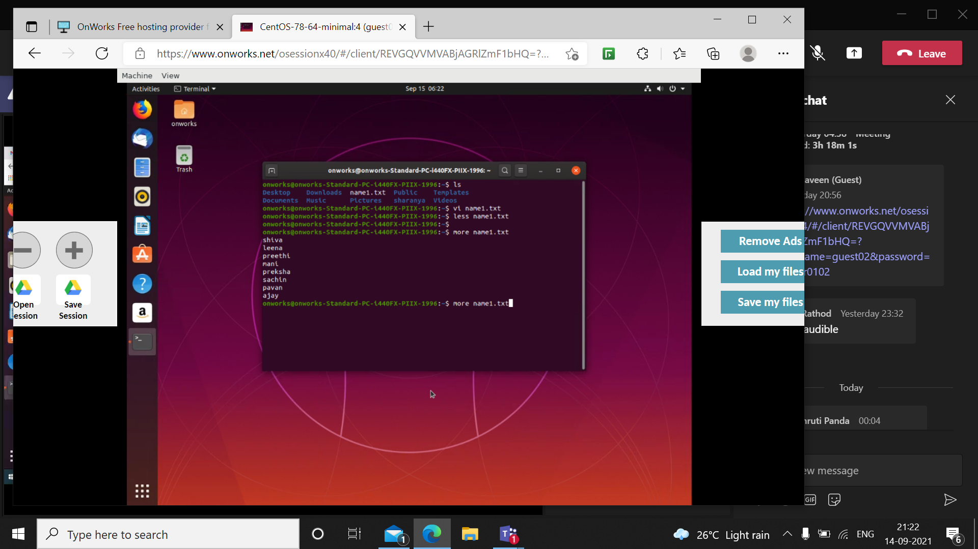

Pressing ‘g’ takes you to the beginning of file in less command

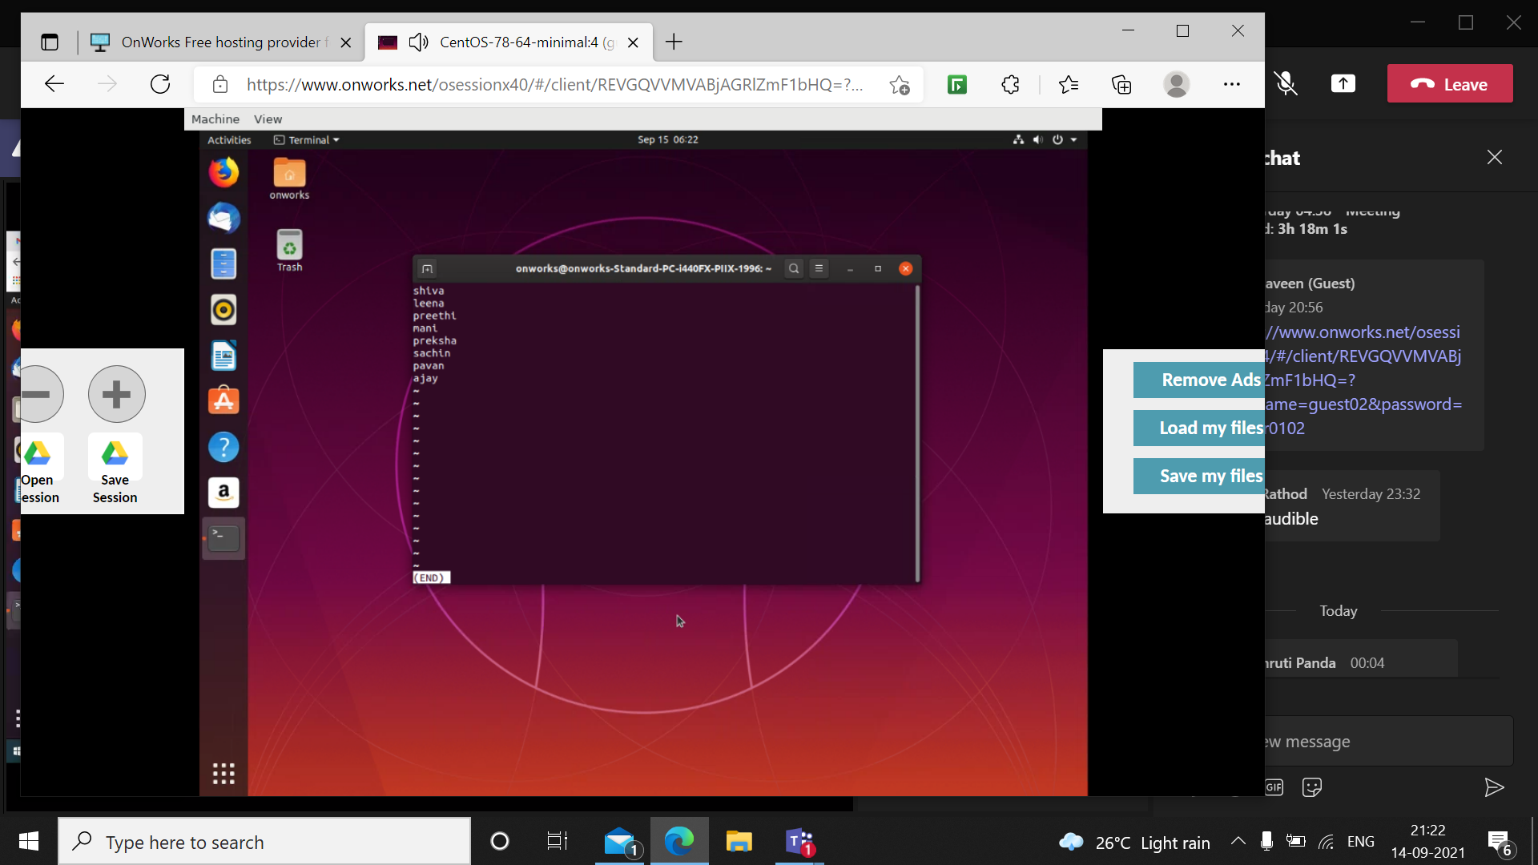

Pressing ‘G’ takes you to the end of the file

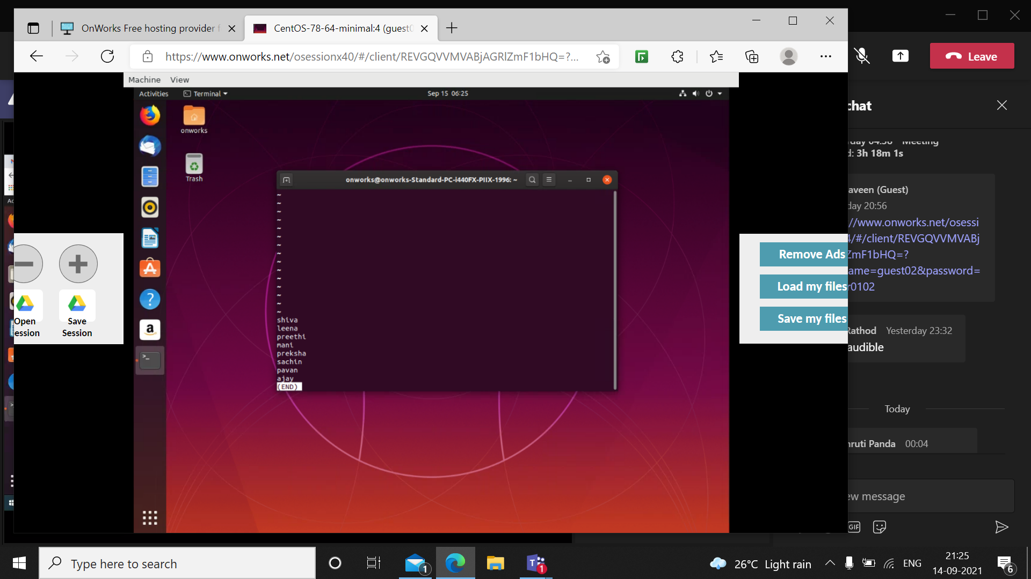

/’pattern’ finds the mentioned pattern, for example /p\* gives the following result

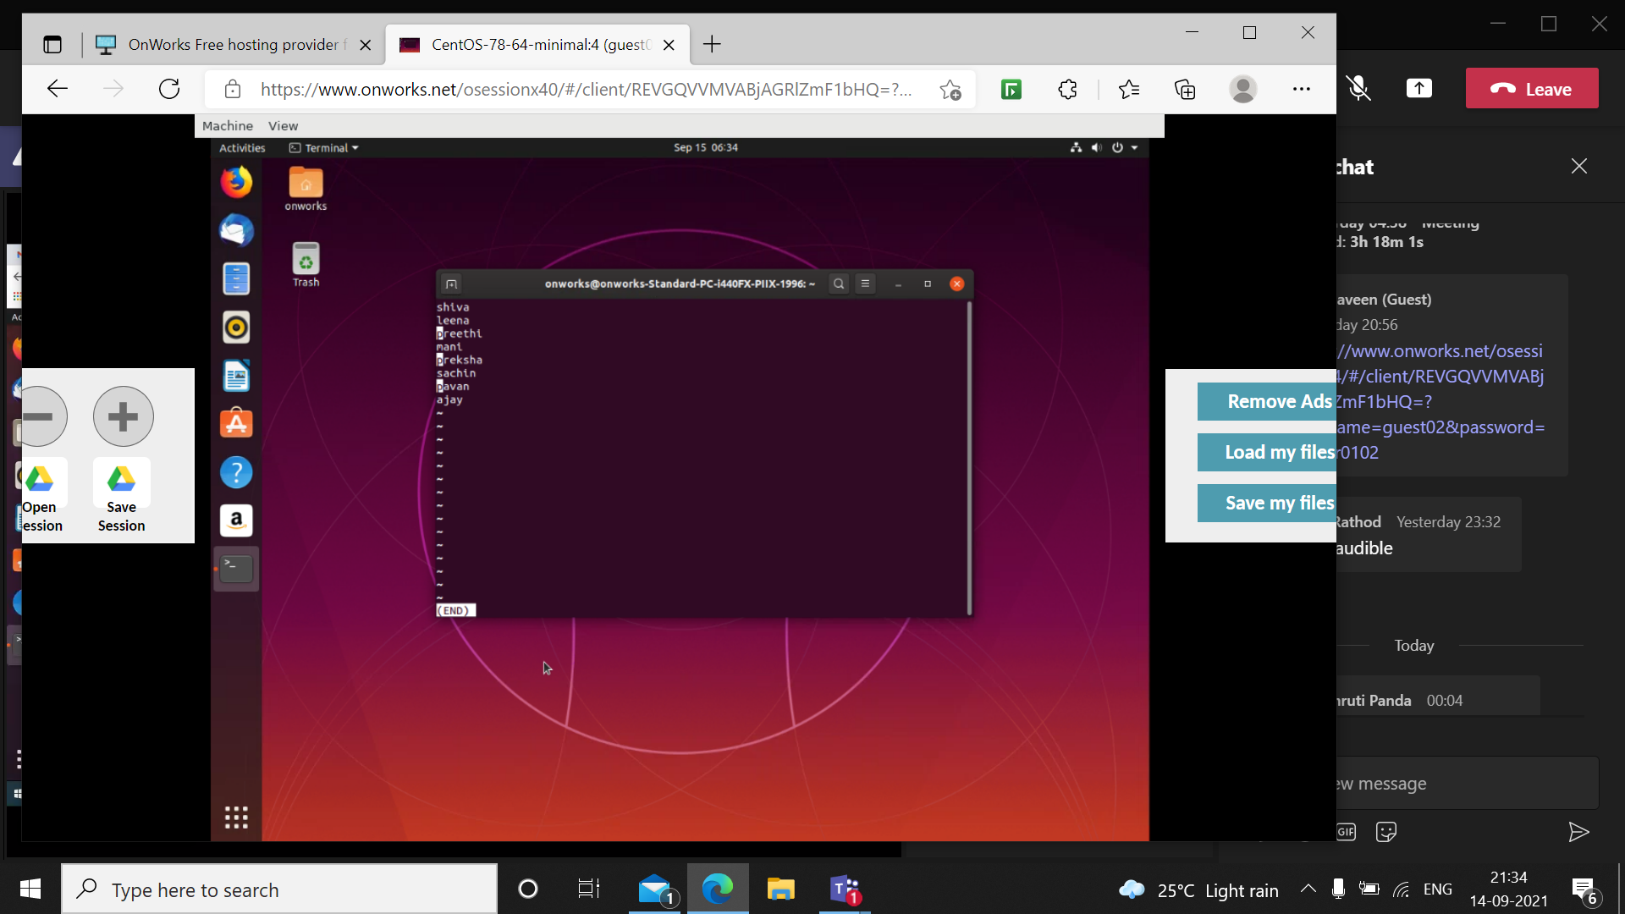

Less file1.extnsion file2.extension file3.extension opens 3 created files. By pressing: n you can move to succeeding files and: p takes to preceding files.

Less –version gives you license of the less command.

Less –x displays the content of the file in the terminal and press q to quit

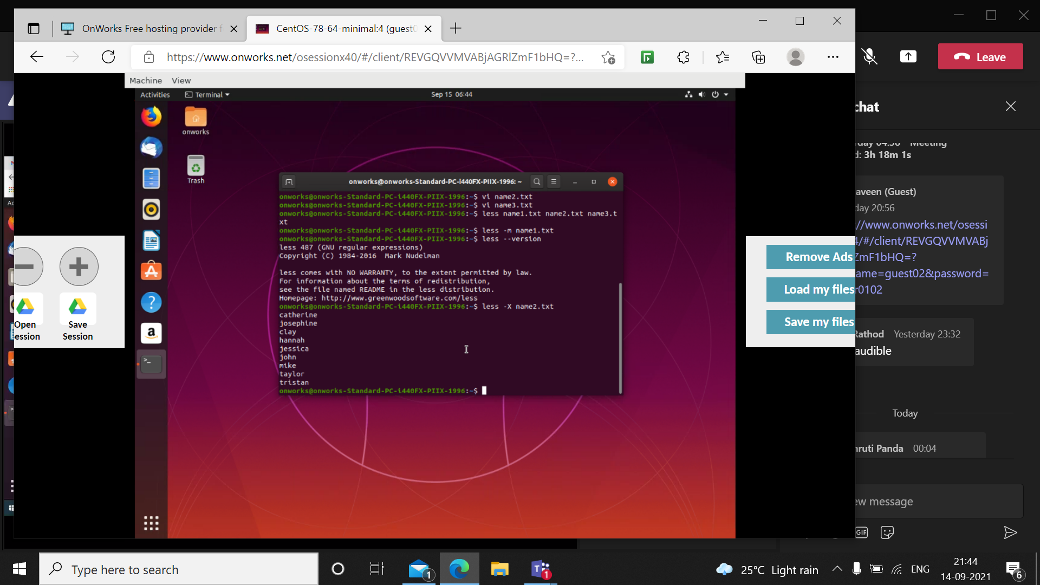

Less –F filename. Extension acts as cat command that displays the contents of the file and goes to the next prompt

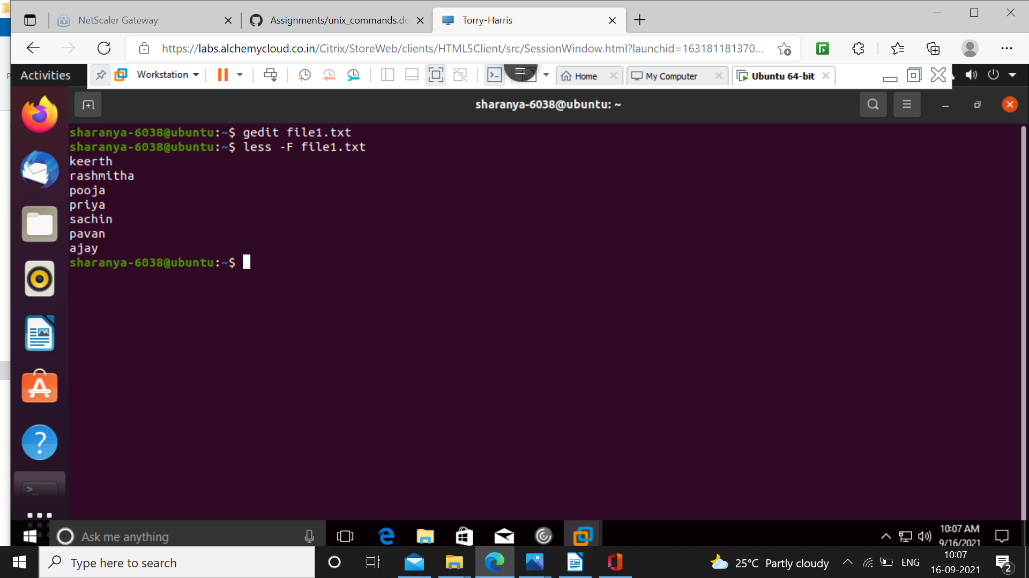

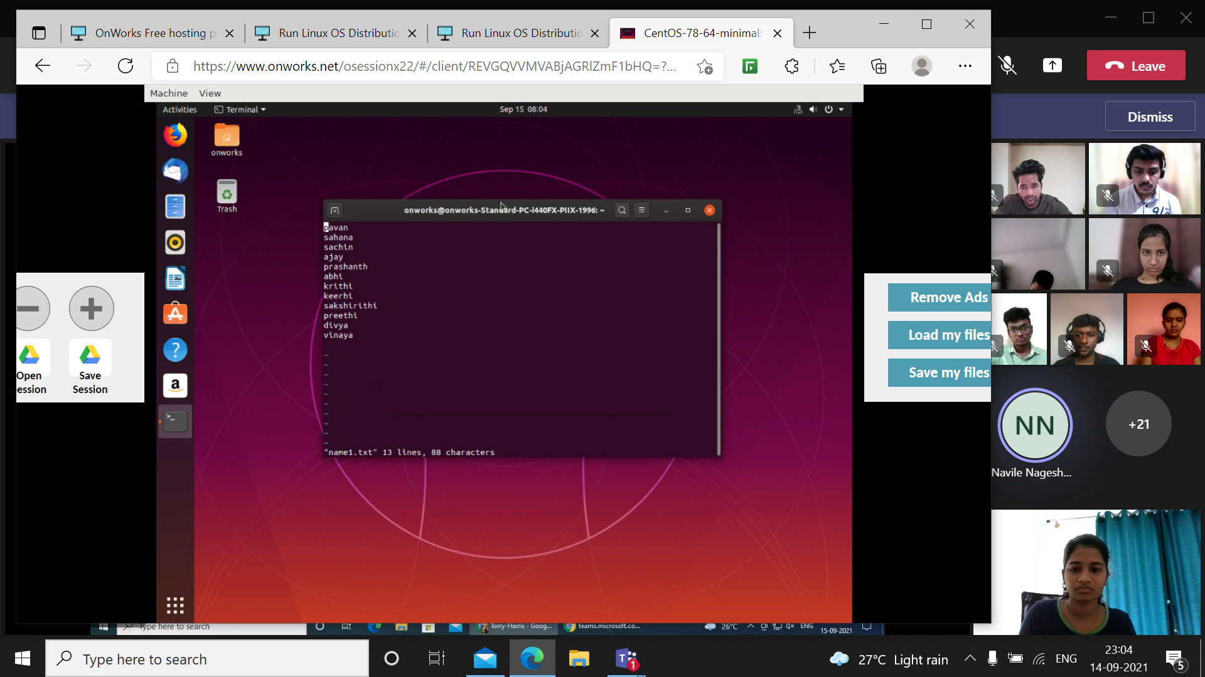

For the above file,

Tail –c –n filename.txt displays n-1 characters from the end. Tail –c n also works the same.

Tail –c +n displays the characters from n I.e., the number given.

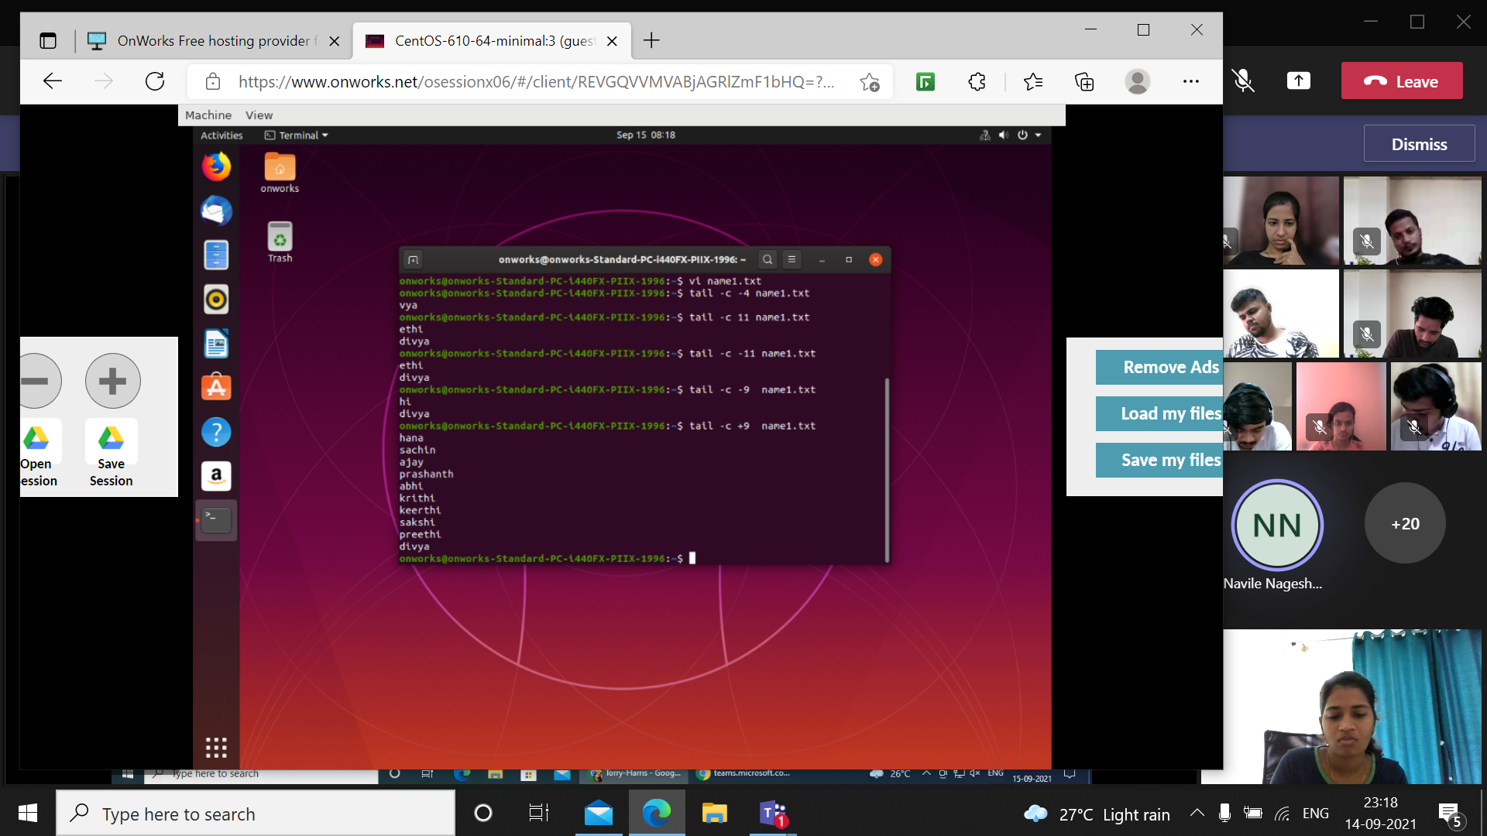

Tail –3 filename. Extension displays last 3 lines of the file, the below command too works the same

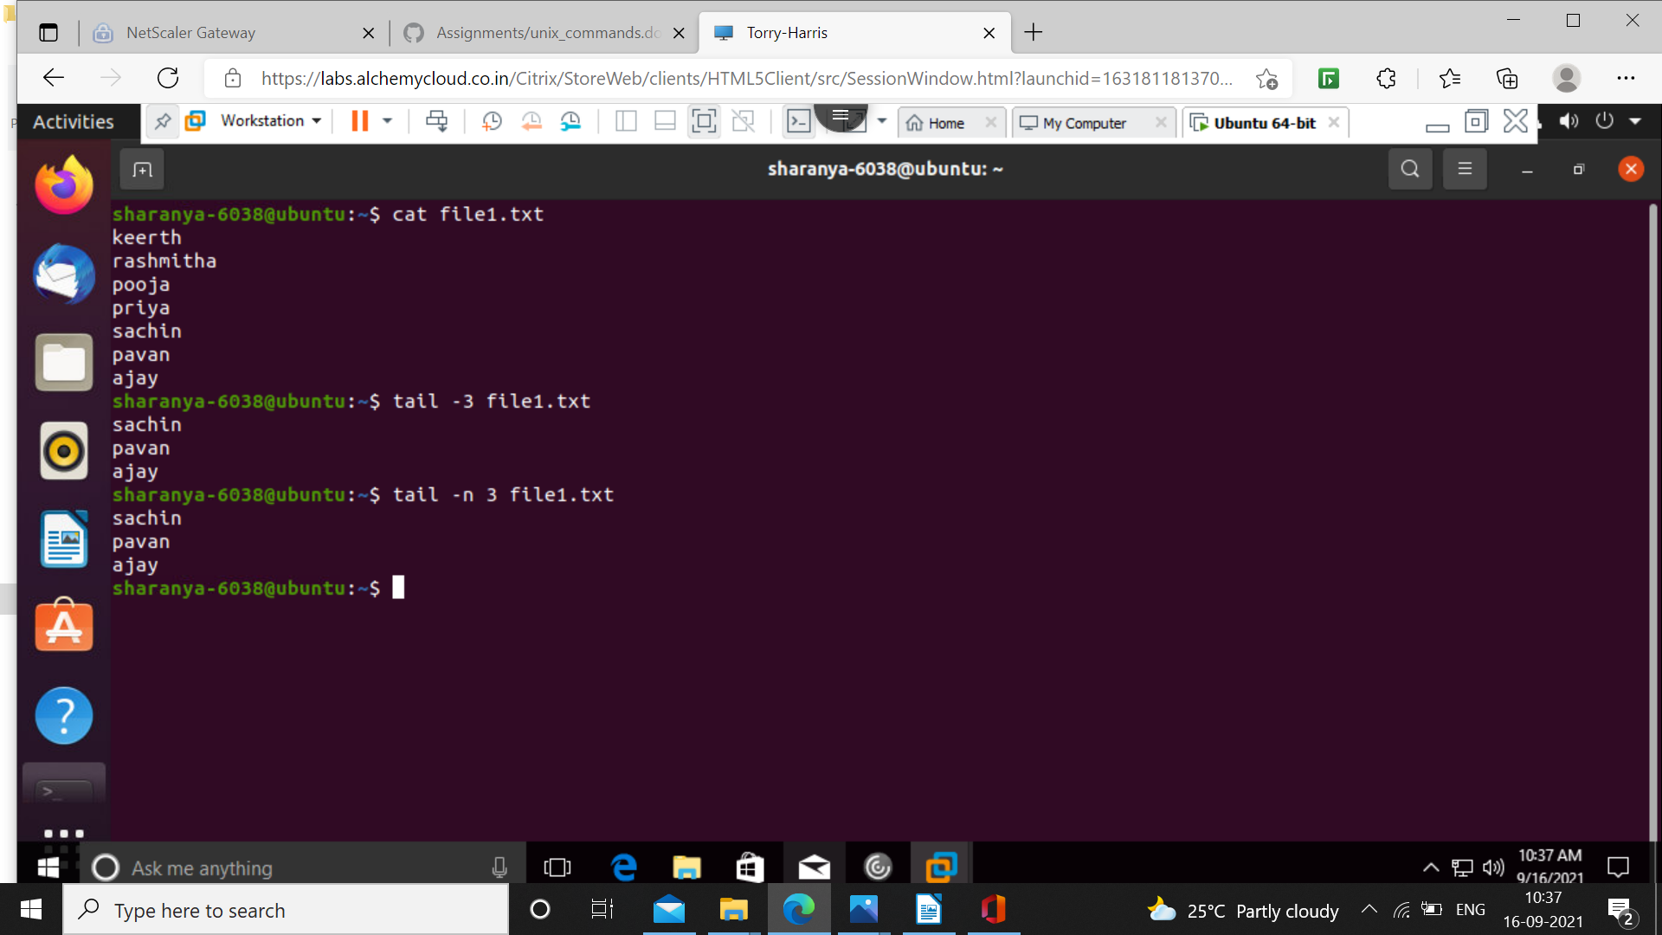

Tail –5 file1.txt|sort first lists last five lines of the file and then sorts them alphabetically.

Cat file1.txt|head –6|tail –3 first lists the file then Apts first 6 lines of the file and then from them lists last three lines.

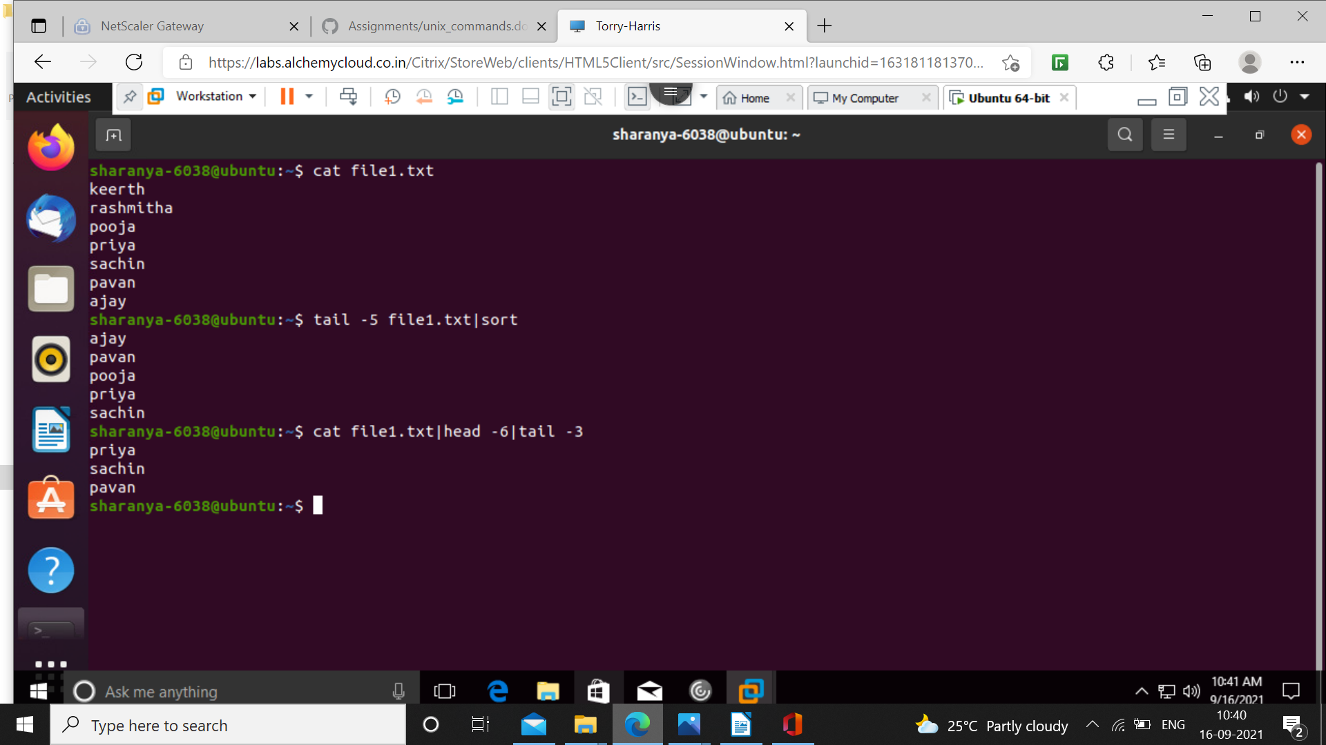

Head –c n prints first n characters of the file.

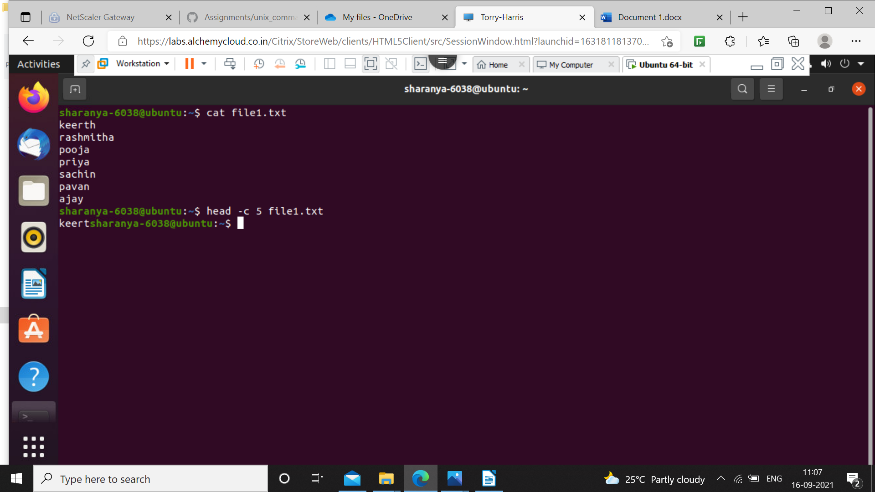

Tr – translates or deletes the specified charecter

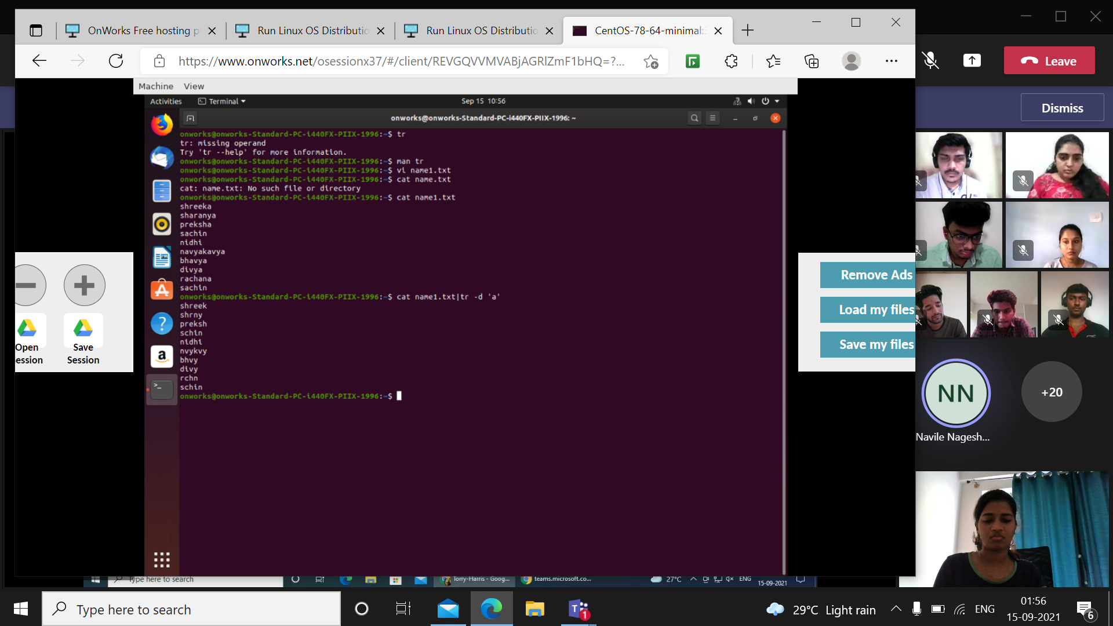

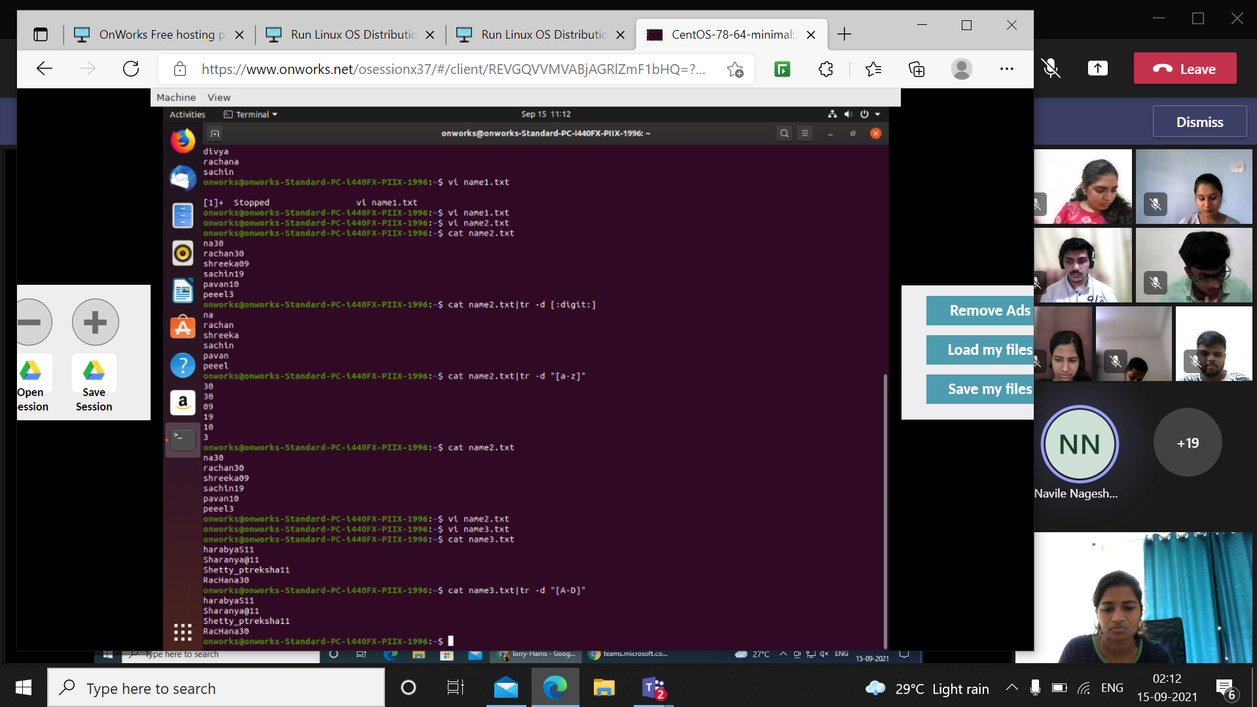

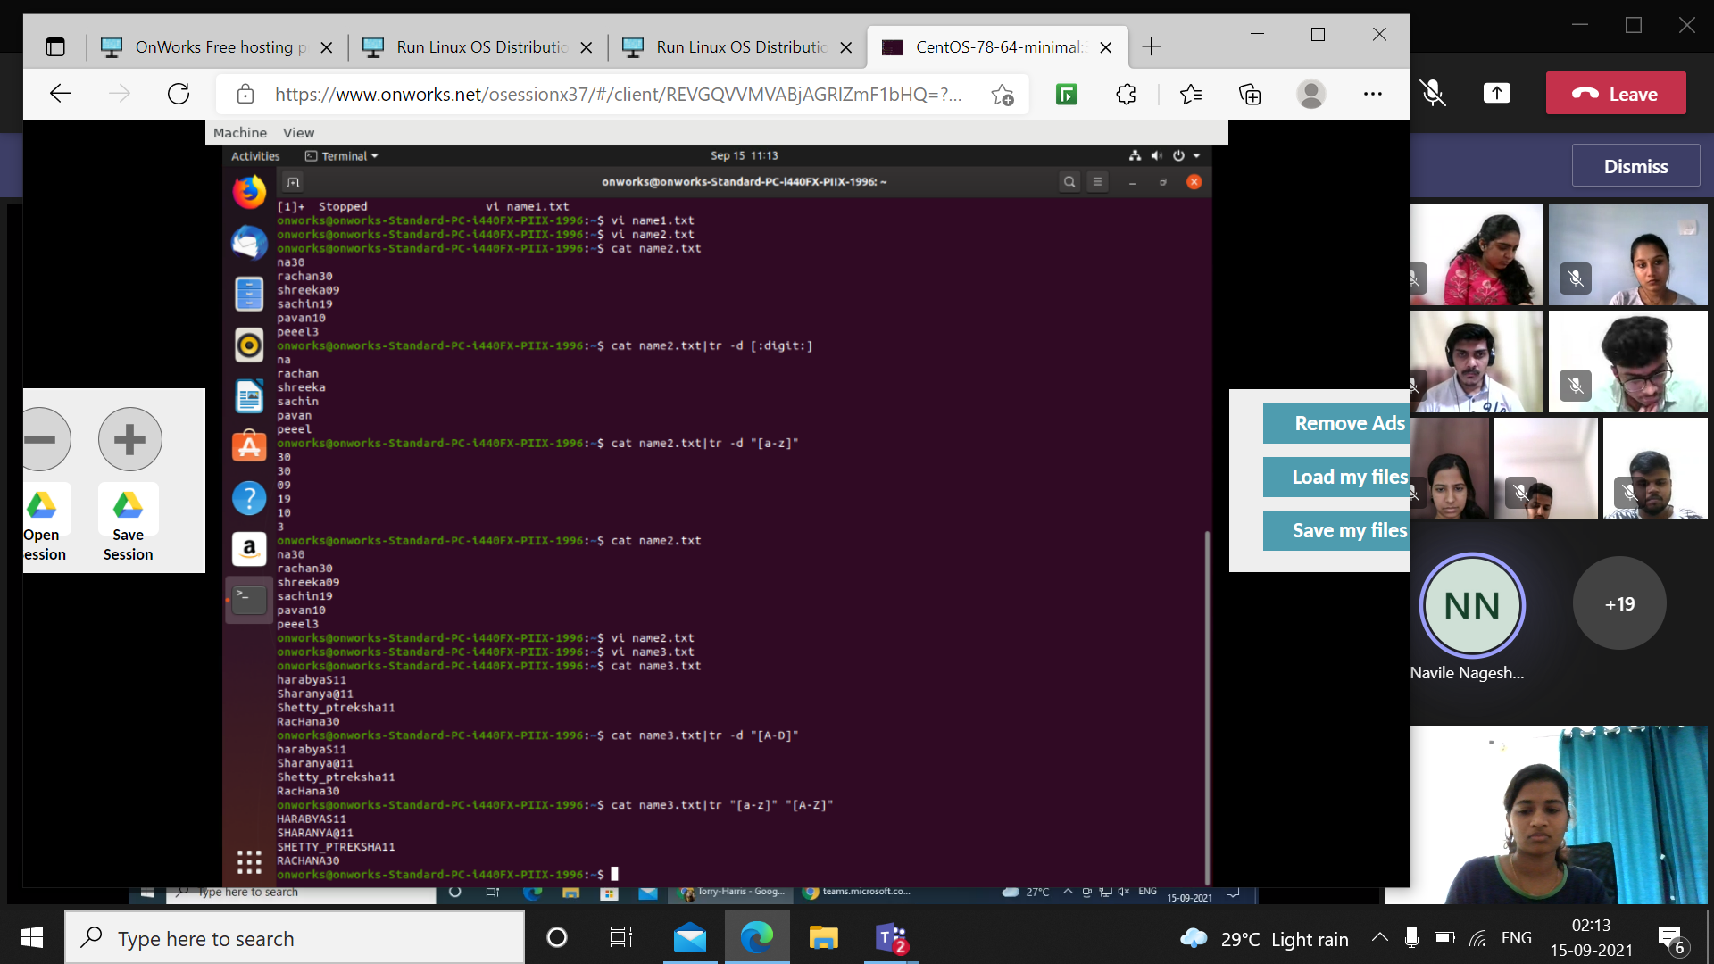

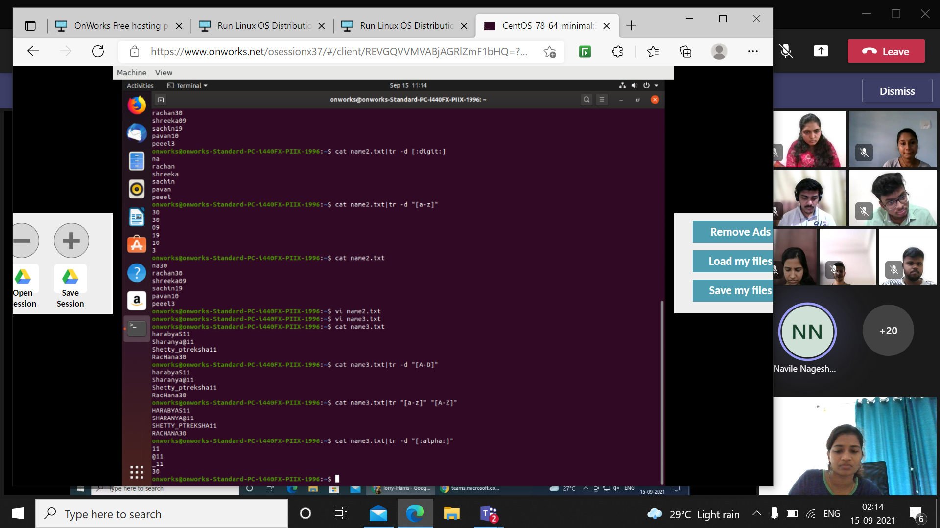

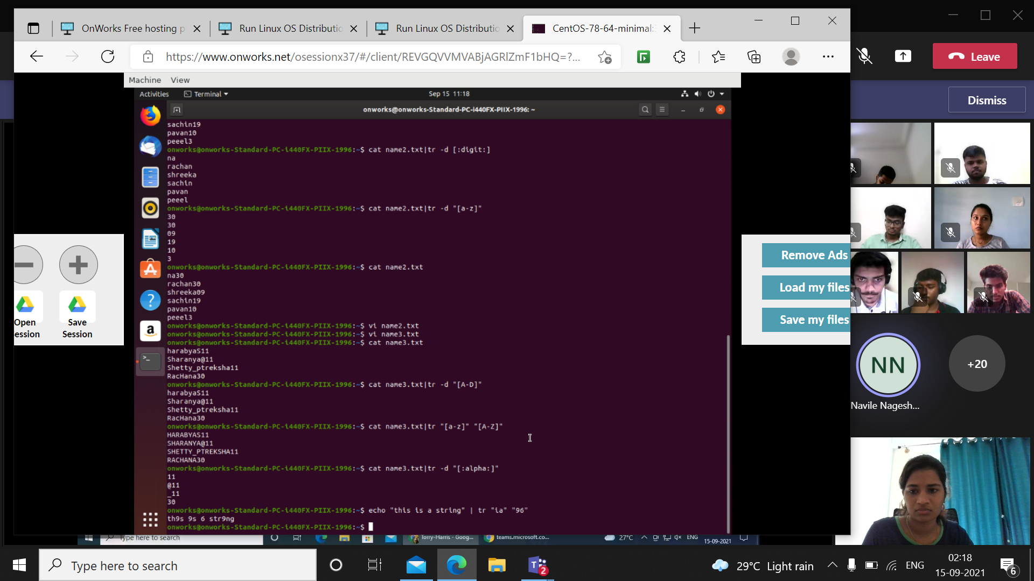

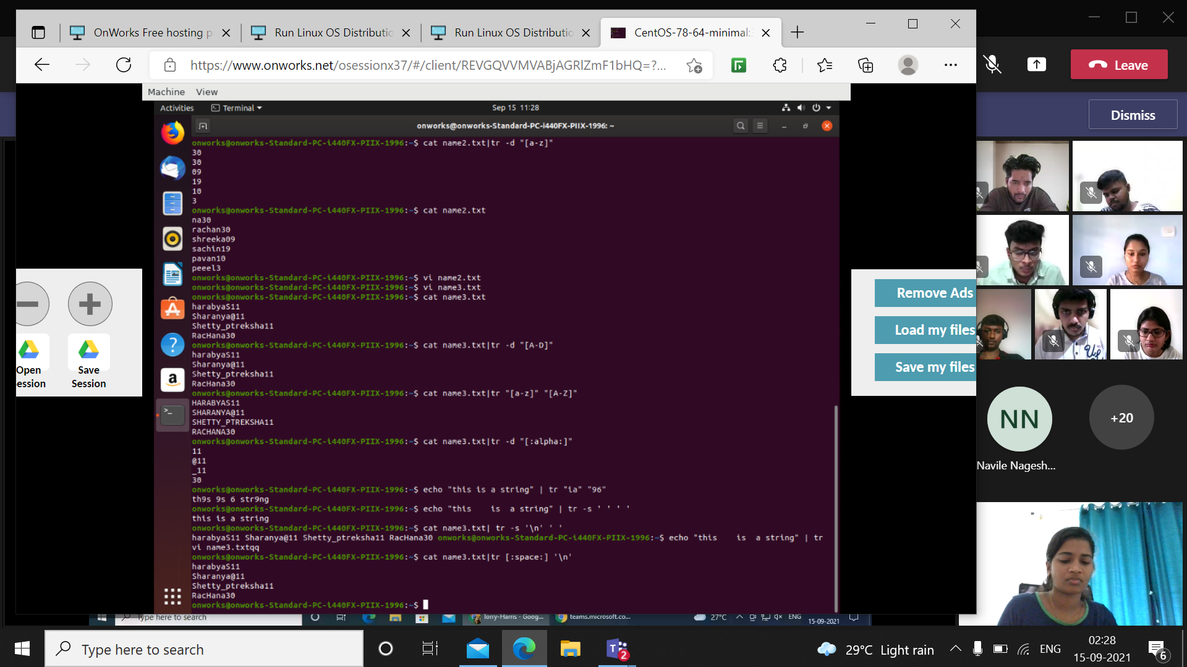

Tr –s is used for replacing

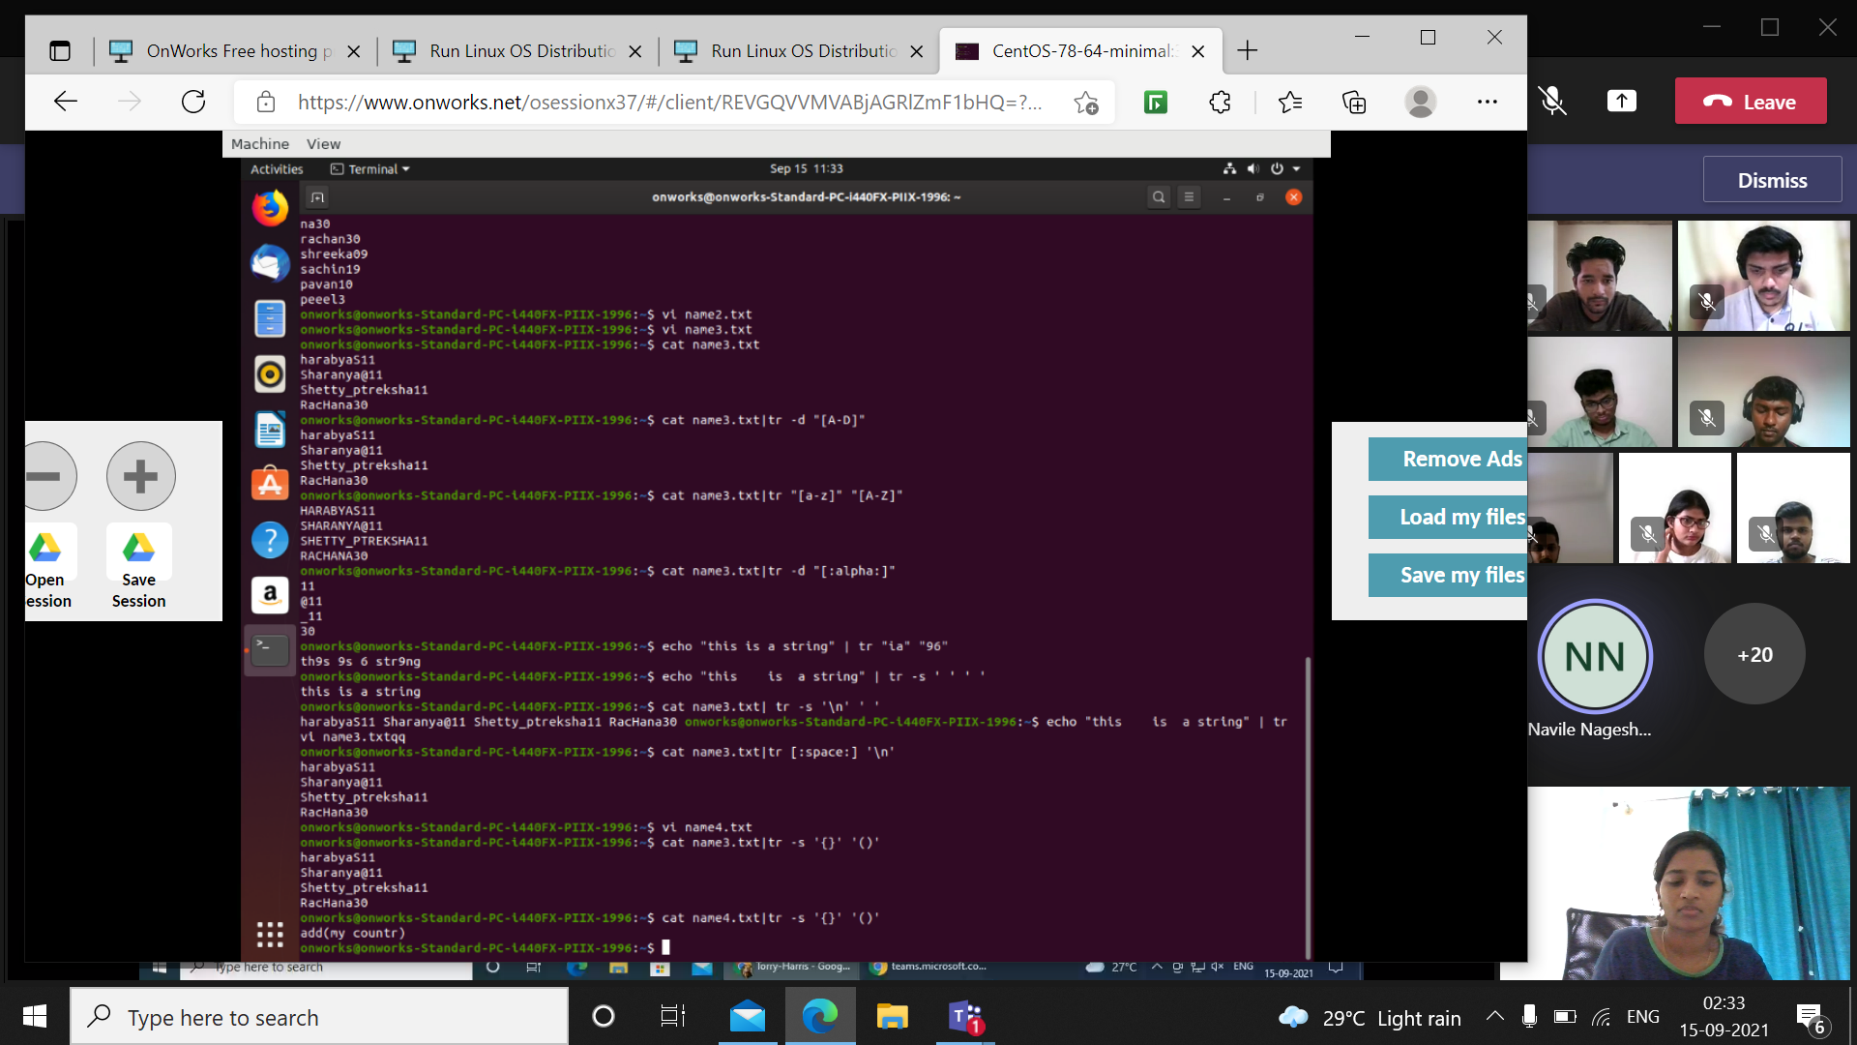

Awk – used for patter scanning and text processing language

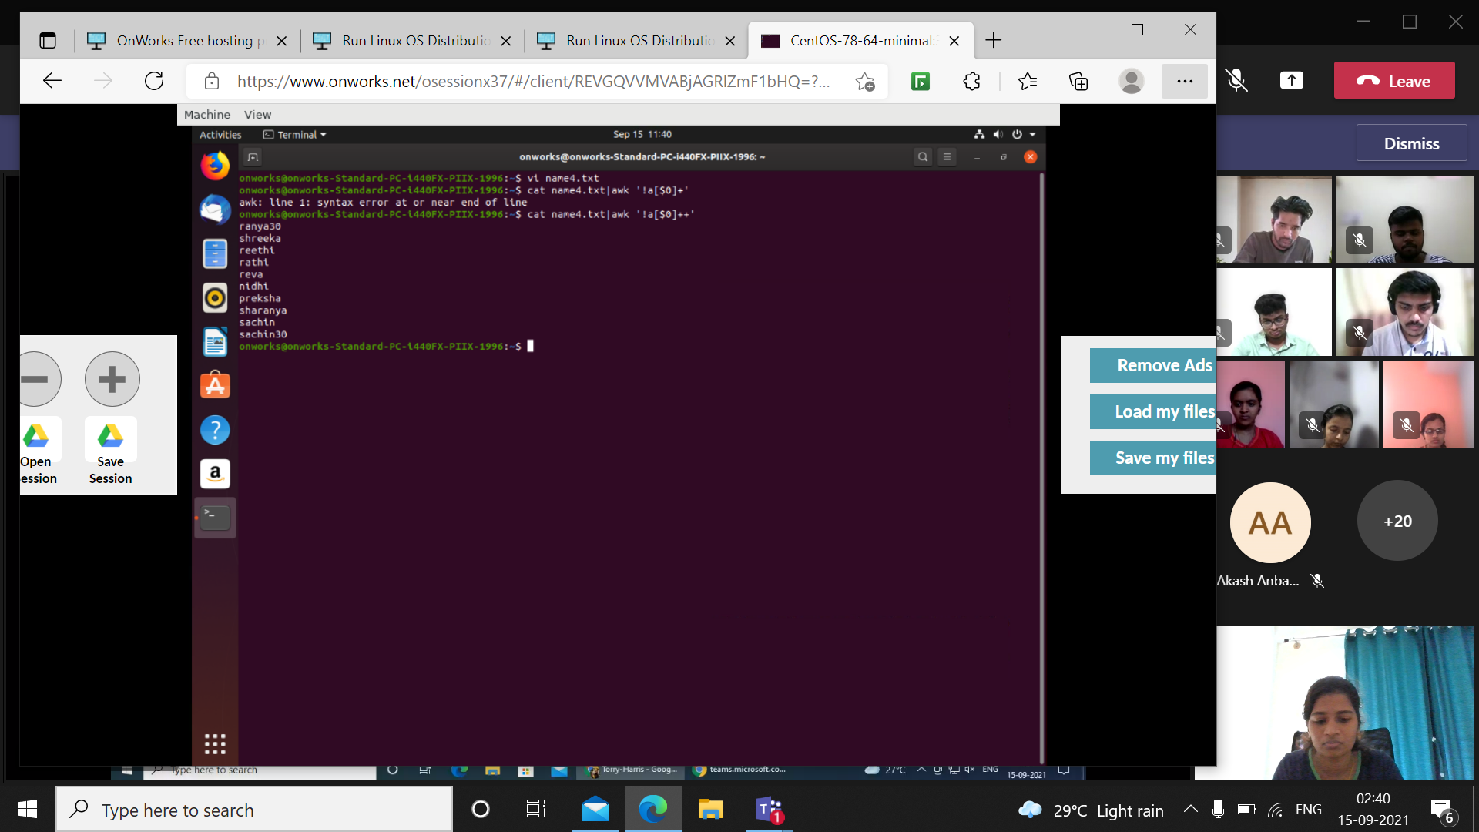

Find command helps in finding files in a directory hierarchy.

File command with –type d displays all the directories.

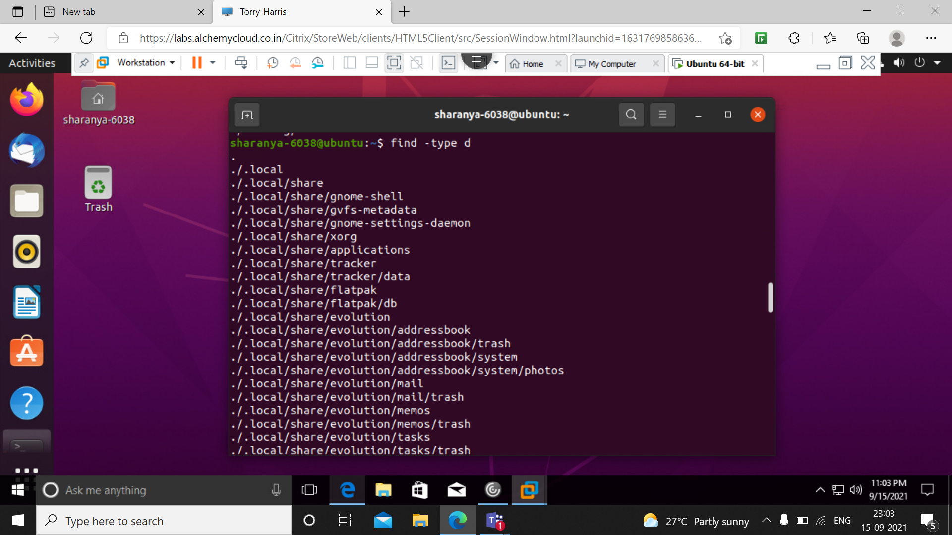

Find command with –type f displays all the files

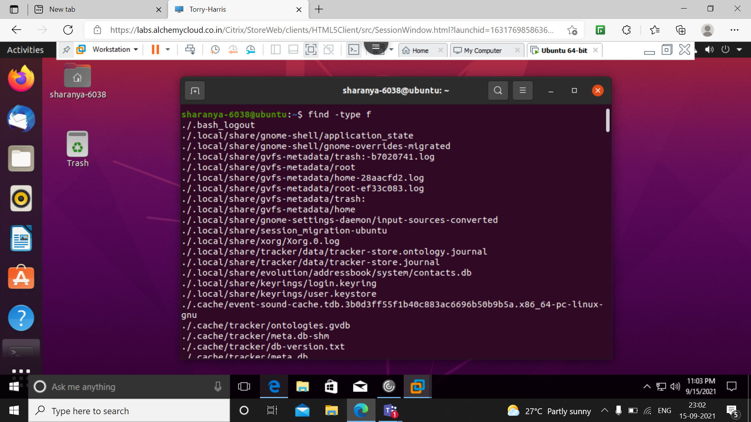

We can also find specific files using filename. -iname finds files with the specified name irrespective of the case.

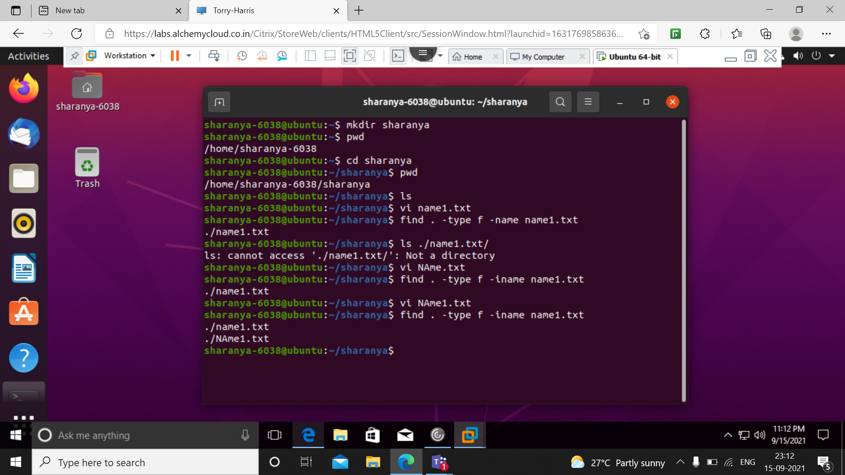

The below command finds files whose name starts with n

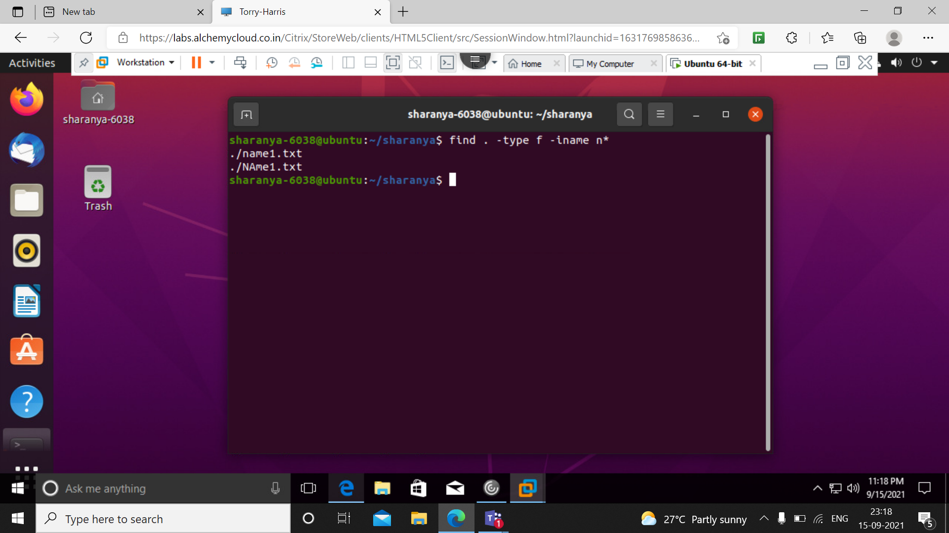

The below command finds files based on their permission

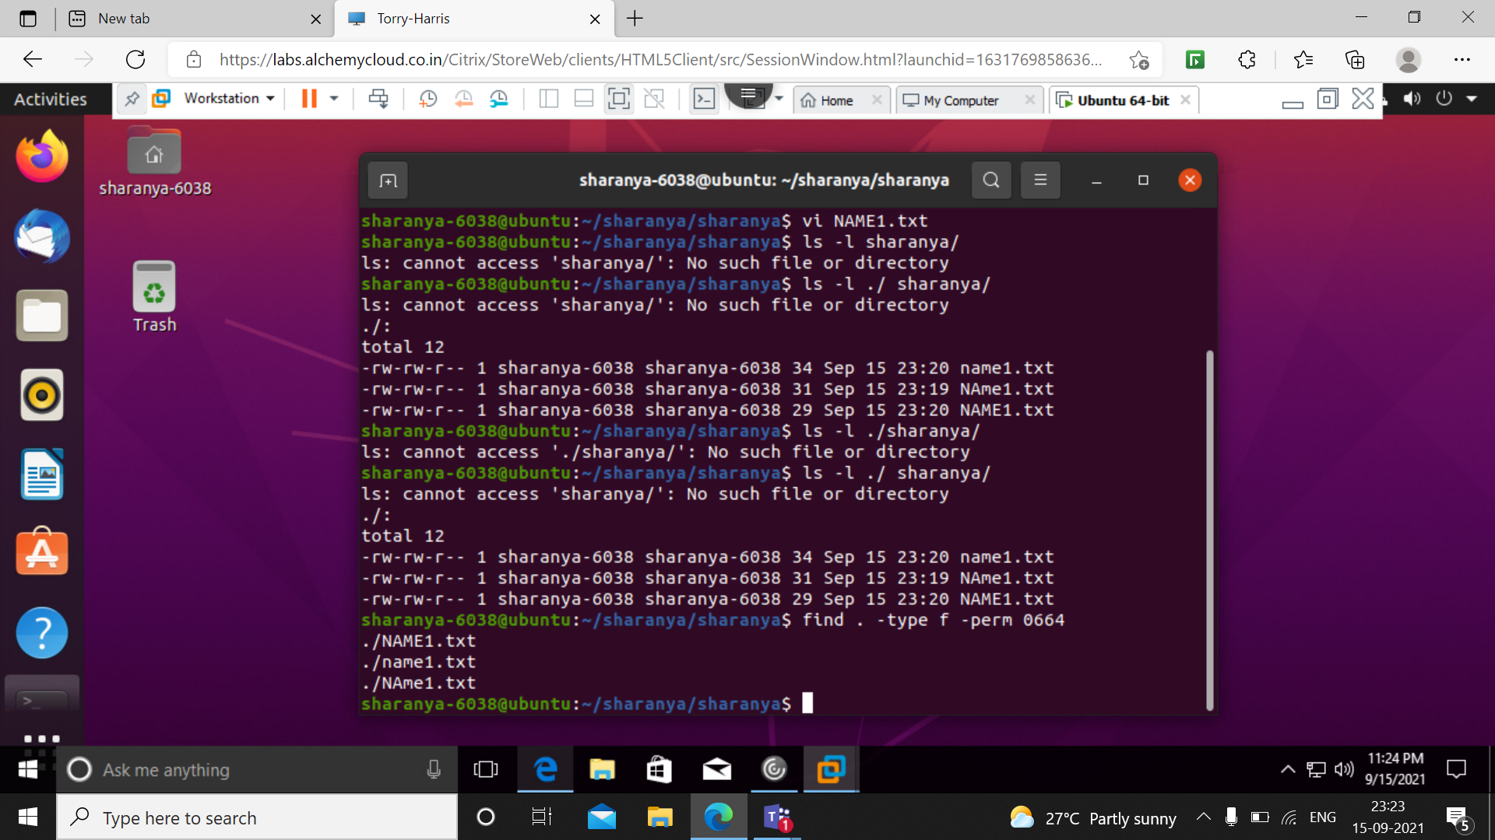

The below command finds the files with permission 0664 and changes it to 555

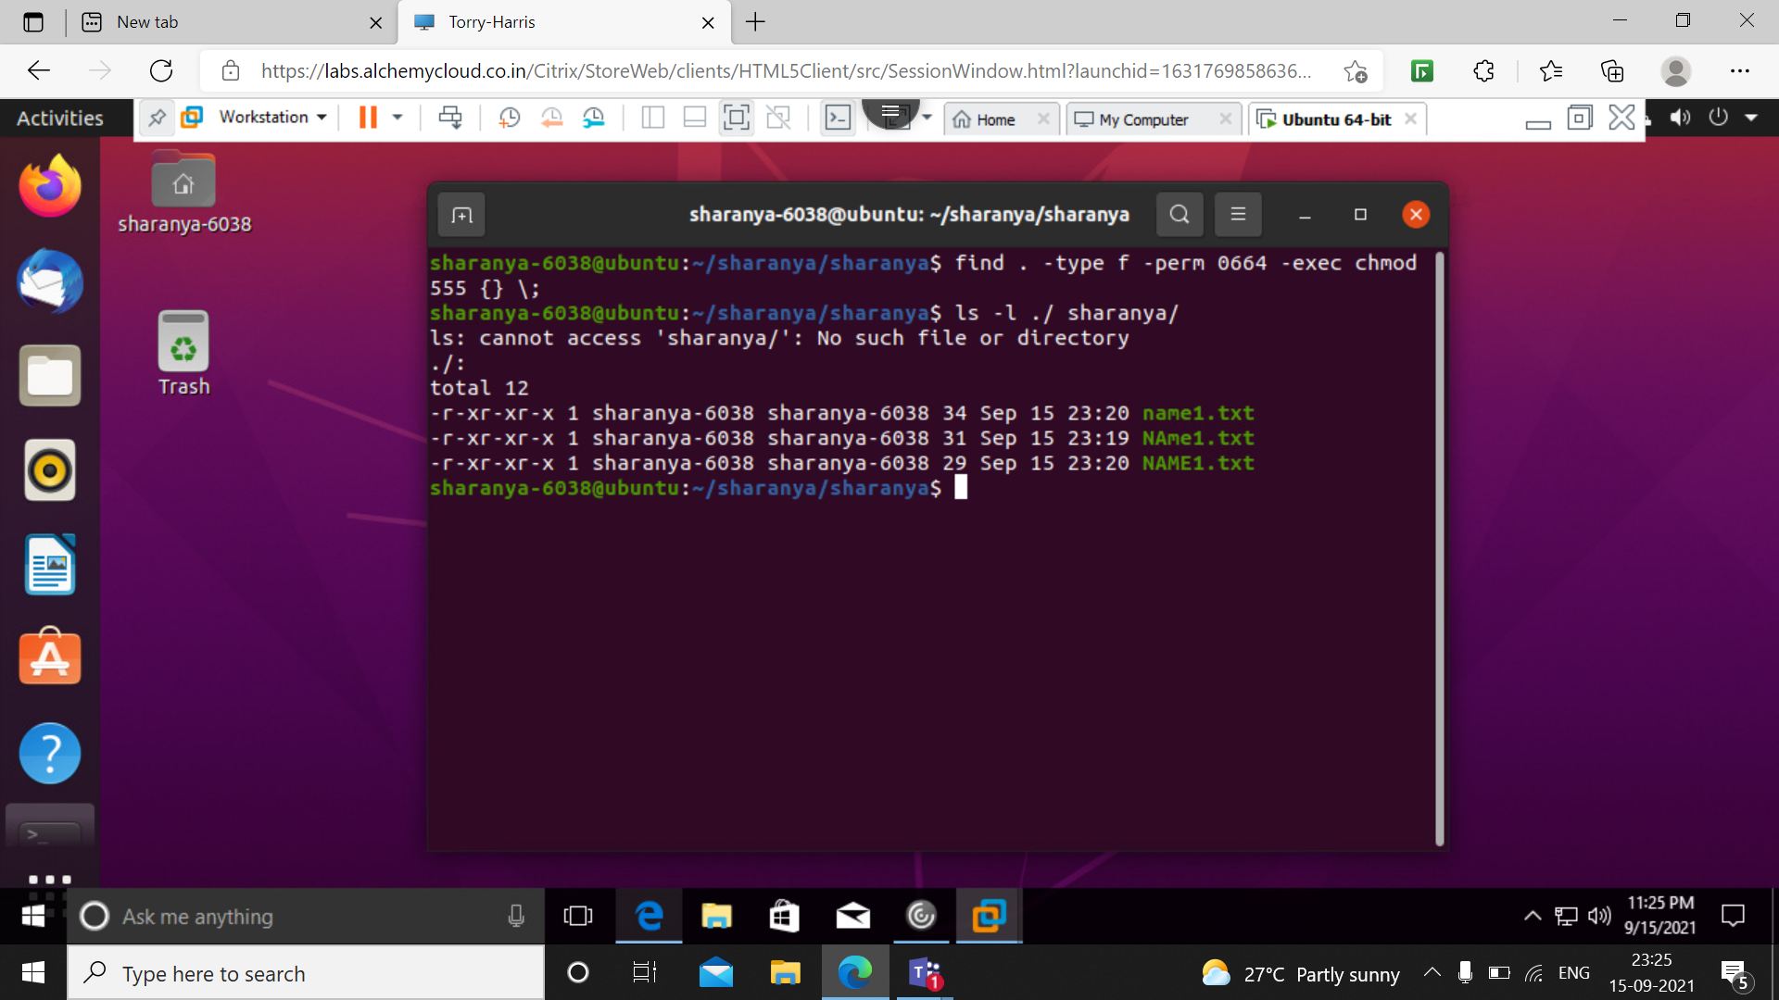

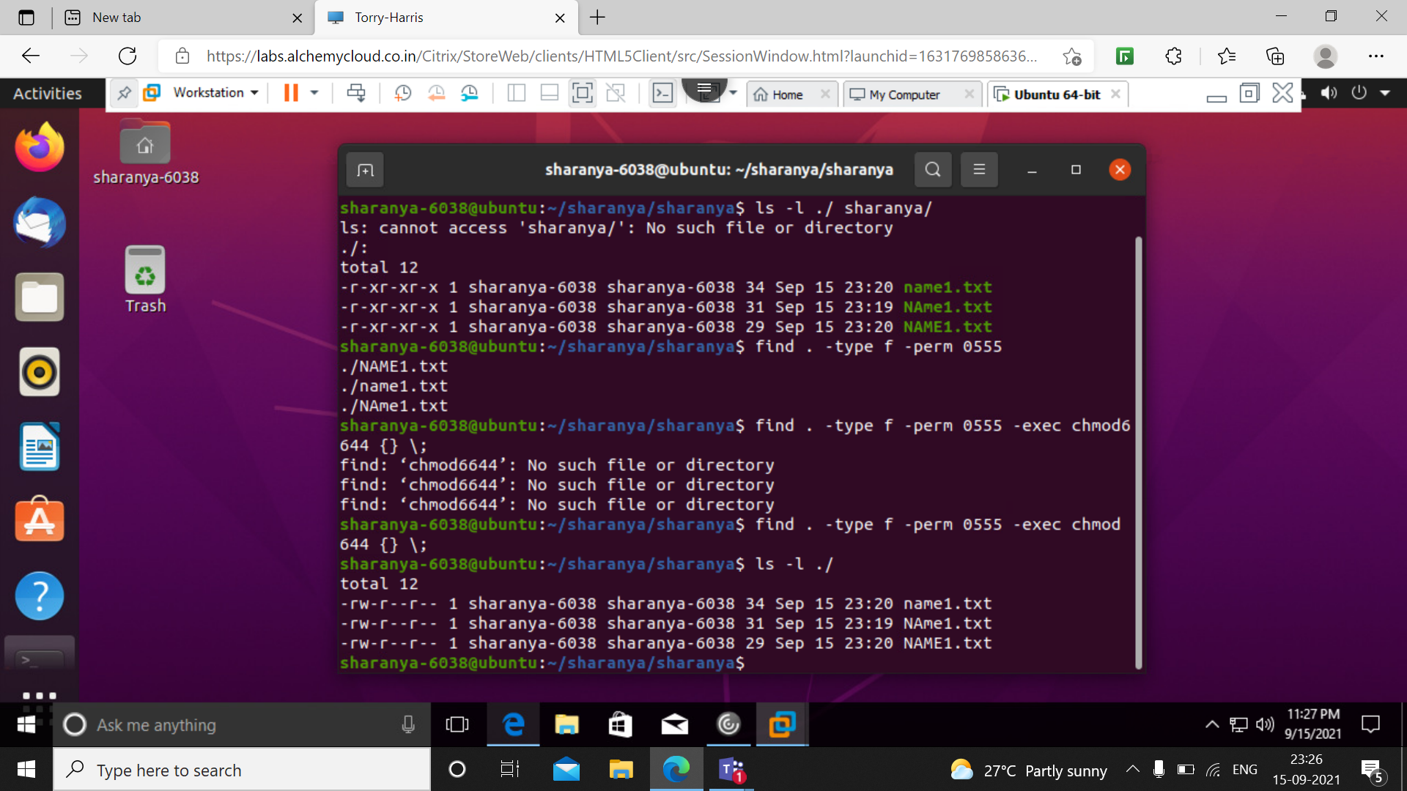

The below commands find files based on the time after its modification.

-mtime of +1 indicates a day, -1 indicates less than a day.

-mmin of +1 indicates more than a minute, -1 indicates less than a minute.

Find command also finds files based on its size.

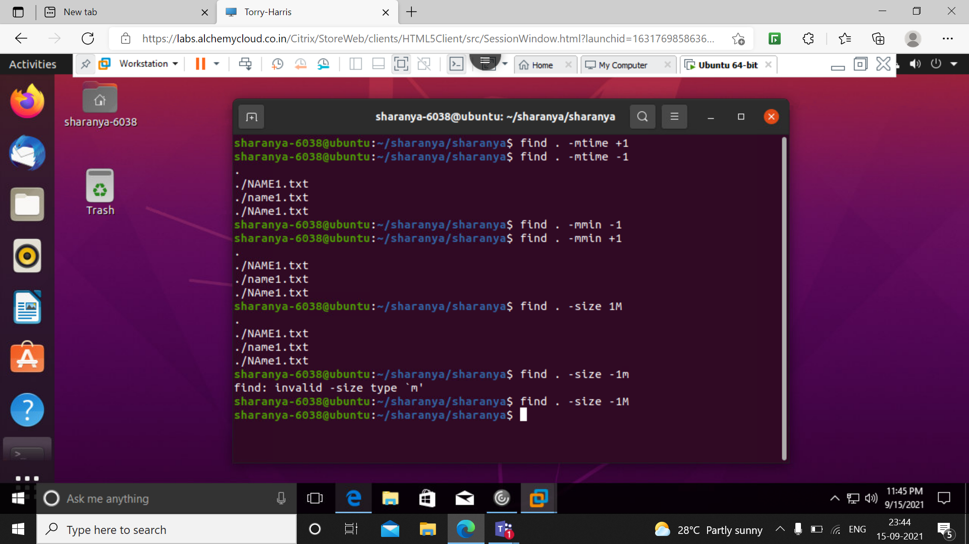

The below command finds and deletes file with confirmation

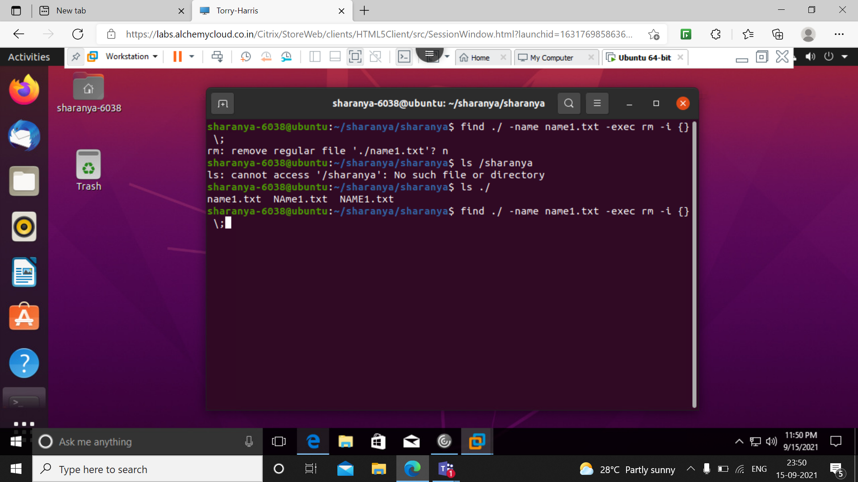

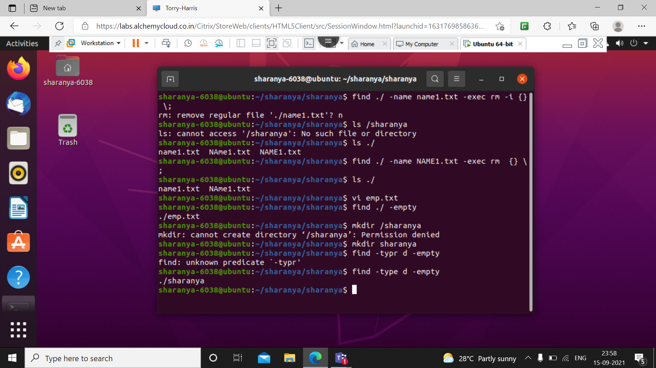

The below command finds and deletes file without confirmation.

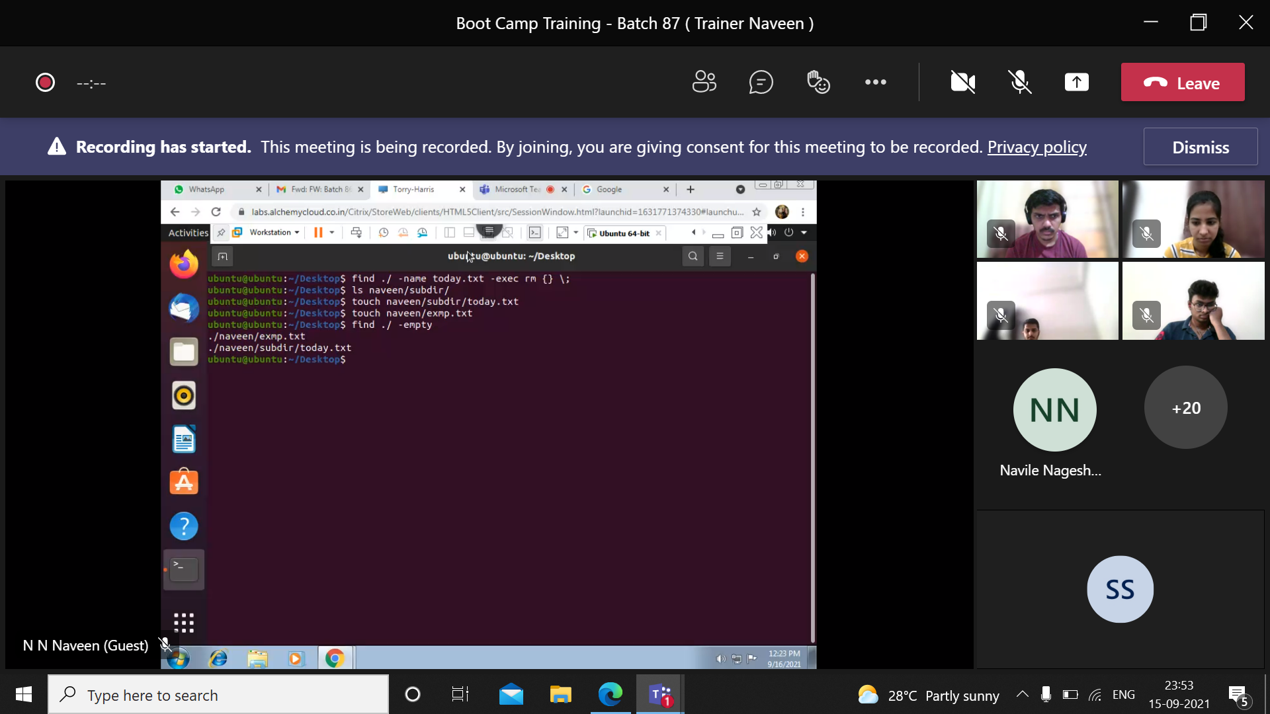

The last command finds lines in the files that ends with .txt that has ‘ar’ in it.

